Grade 5
Pentatonic Music

Description: | Students will:  Modify the size and color of an ellipse from Supplies  Make a script with the forward tile.  Use the Sound tiles to assign a frequency to the ellipse.  Choose specific frequencies for the sound tiles.  Use conditional statement: if obtrudes.  Use a conditional statement to control when a script is paused.  Use a random number to change the heading.  Make copies of the ellipse modify their color, size and script.  Use a playfield to limit the motion.  Experiment with different lengths and widths for the playfield.  Experiment with forward by values to control the polyphony.  Experiment with starting location of shapes to control the polyphony.  Experiment to control the location so the shapes never touch simultaneously, or so they do touch simultaneously every cycle.  Add a title.  Add a flap if additional information is needed.
Project View | 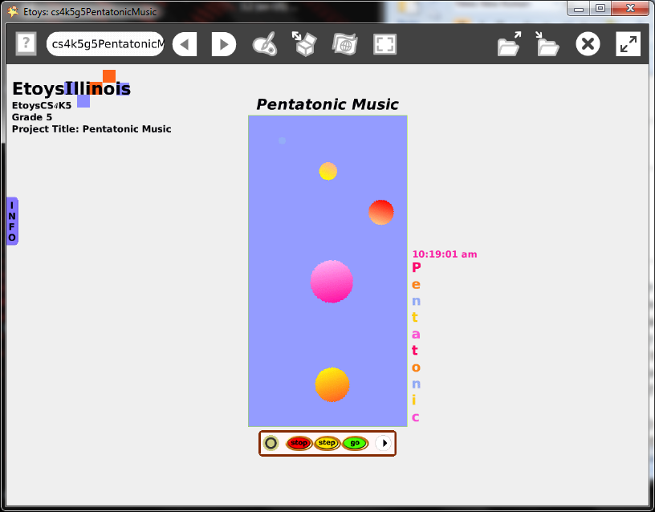
Subject: | Mathematics, Music
Etoys Quick Guides | Click the question mark in Etoys to open the set of interactive tutorials for basic tools and techniques.
Vocabulary: | Obtrudes, random, patterns, rhythm, polyphony, hertz, Hz, prefix, penta, multiply, divide, x and y locations, forward by, heading. ratio, scale factor
Lesson 1:  Halo: Color Properties Sheet  Script Tiles: Forward and Turn  Script Tiles: Tests  Script Tiles: Sound Category  Halo: Size, Color, Copy  Navigator Bar: Keep Find Project | Get an ellipse from Supplies. Modify the color using its fill and border tiles.  Make a script with the forward by tile.  Add two conditional statements.  The first test controls the pitch by specifying a frequency. This project uses the pentatonic scale but other frequencies and scales can be used.  See the chart below.  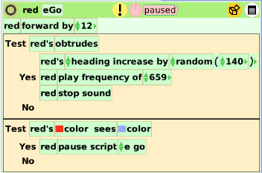  Make copies of the ellipse and change their frequencies, size, color, and scripts.  There will be noise.  Discuss why the piece of music will be different every time it plays. What should be changed so that it plays the same every time?  Give students time to experiment.  How is the music different if all the shapes are in the same position at the start?  Can the rhythm be controlled with the forward speed so that there is a regular rhythm?  Keep the project. Call it: namePentatonic. E.g. KatePentatonic
Lesson 2:  Halo: Size, Color, Copy  Script Tiles: Scale Factor | Get a playfield from Supplies. Use playfield’s Viewer category fill and border to change the color.  Put the ellipses in it. Students should make as many copies and modify them as they want for their music.  Experiment with the size of the playfield to control the polyphony.  Experiment forward speeds to control the rhythm. Listen.  Multiply the speed of one ellipse to make the speed of another. Multiply its speed to make the speed of a third ellipse. Experiment with ratios. Listen.  Experiment to control size and speed so that one circle’s pitch is repeating twice as often as another’s pitch. Or make one pitch the double of another. Listen.  Use the scale factor to make exact size ratios between the ellipses sizes.  Give students time to experiment.  Give students time to try other student’s projects.  Give students time to revise their project.  Keep the project.
Standards: | Common Core Standards  Mathematics: 5.OA.3; 5.NF.1.2.5.6; 5.MD.1  Bloom’s Taxonomy/Cognitive Domain:  Knowledge: describes, selects  Comprehension: estimates  Application: constructs, discovers  Analysis: analyzes, experiments  Synthesis: categorizes, explains  Evaluation: compares, reviews  NETS:  1. a, b, c  4. a, b, c, d
Resources: | Etoys Help Quick Guides: always available in Etoys. Open Etoys and click the question mark to open a set of interactive tutorials of basic tools and techniques.  www.etoysillinois.org projects, lesson plans, software download  www.mste.Illinois.org more math, science, and technology resources  www.corestandards.org Common Core Standards  www.squeakland.org software and Etoys projects  www.nctm.org Standards and Focal Points for each grade level
kh February 2011

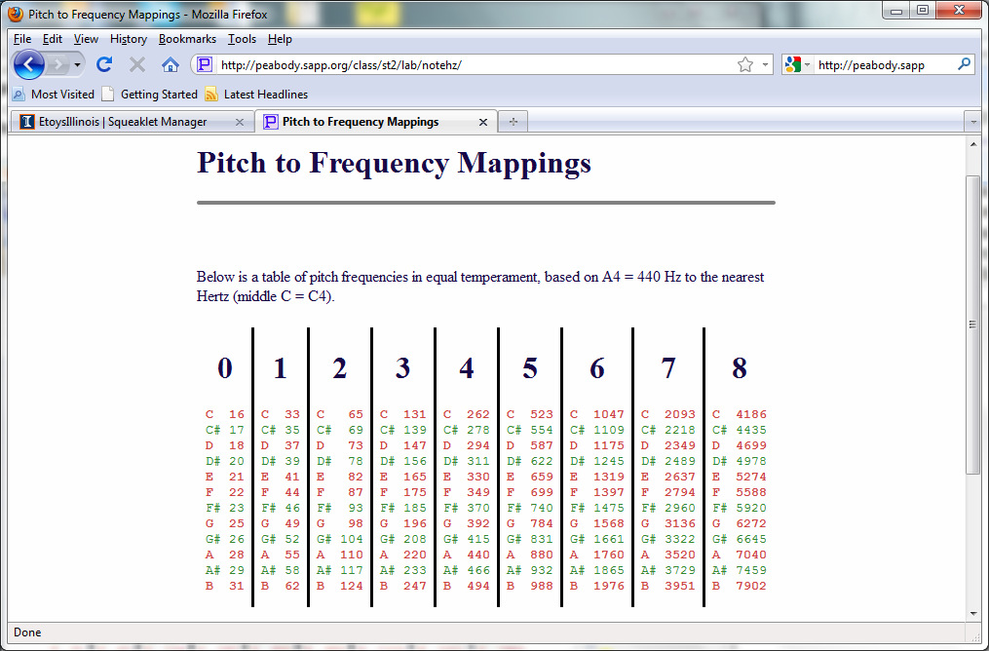
http://peabody.sapp.org/class/st2/lab/notehz/

